Customer Feedback System

Customer – Story 1

Main Screen :

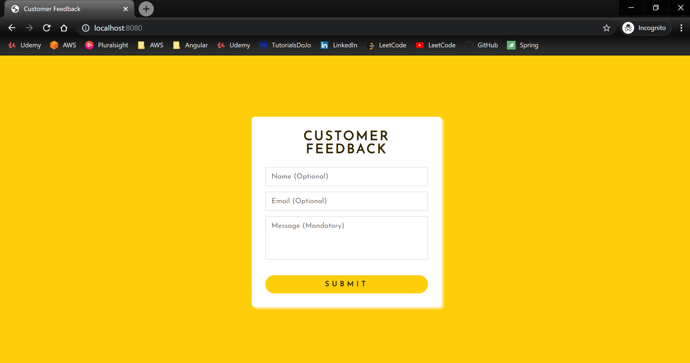

Submission of Feedback :

- Negative Scenario:

Assumption: Feedback is expected to be a minimum to 30 characters and is mandatory

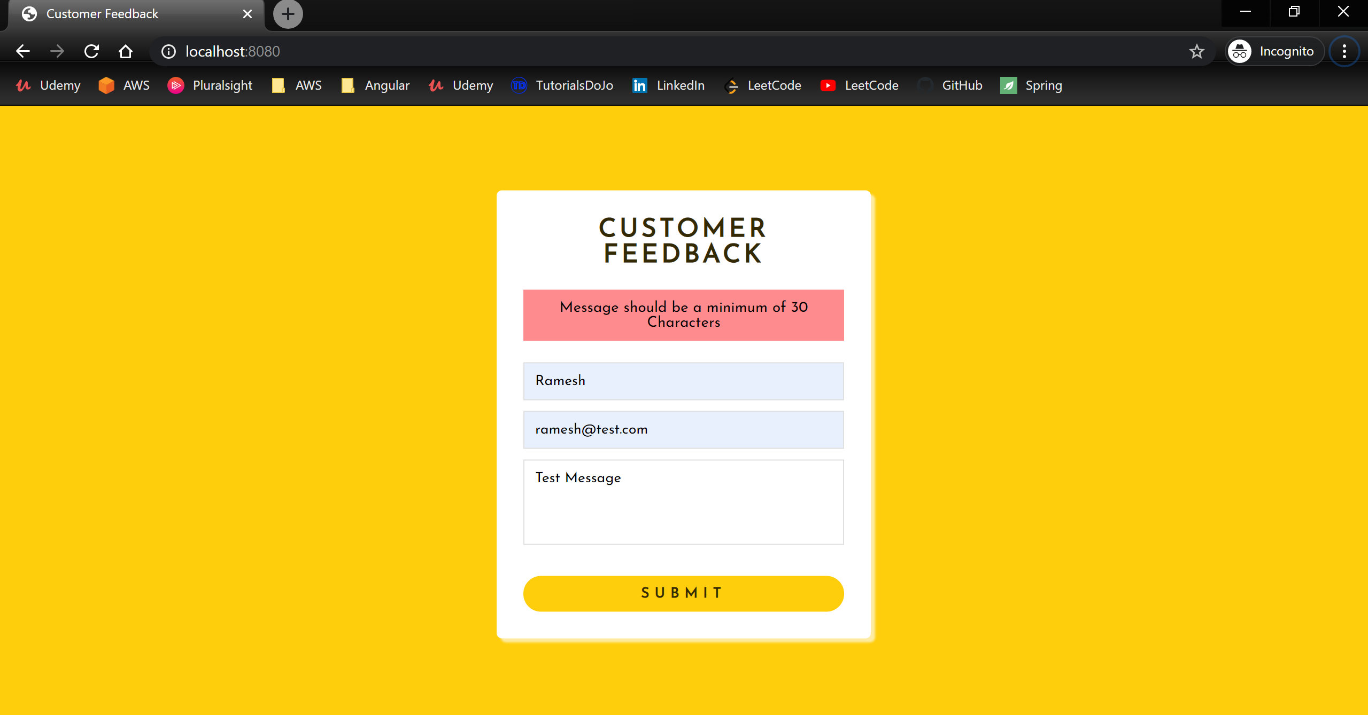

- Positive Scenario
Assumption: Name & email left blank. Message length is more than 30 characters

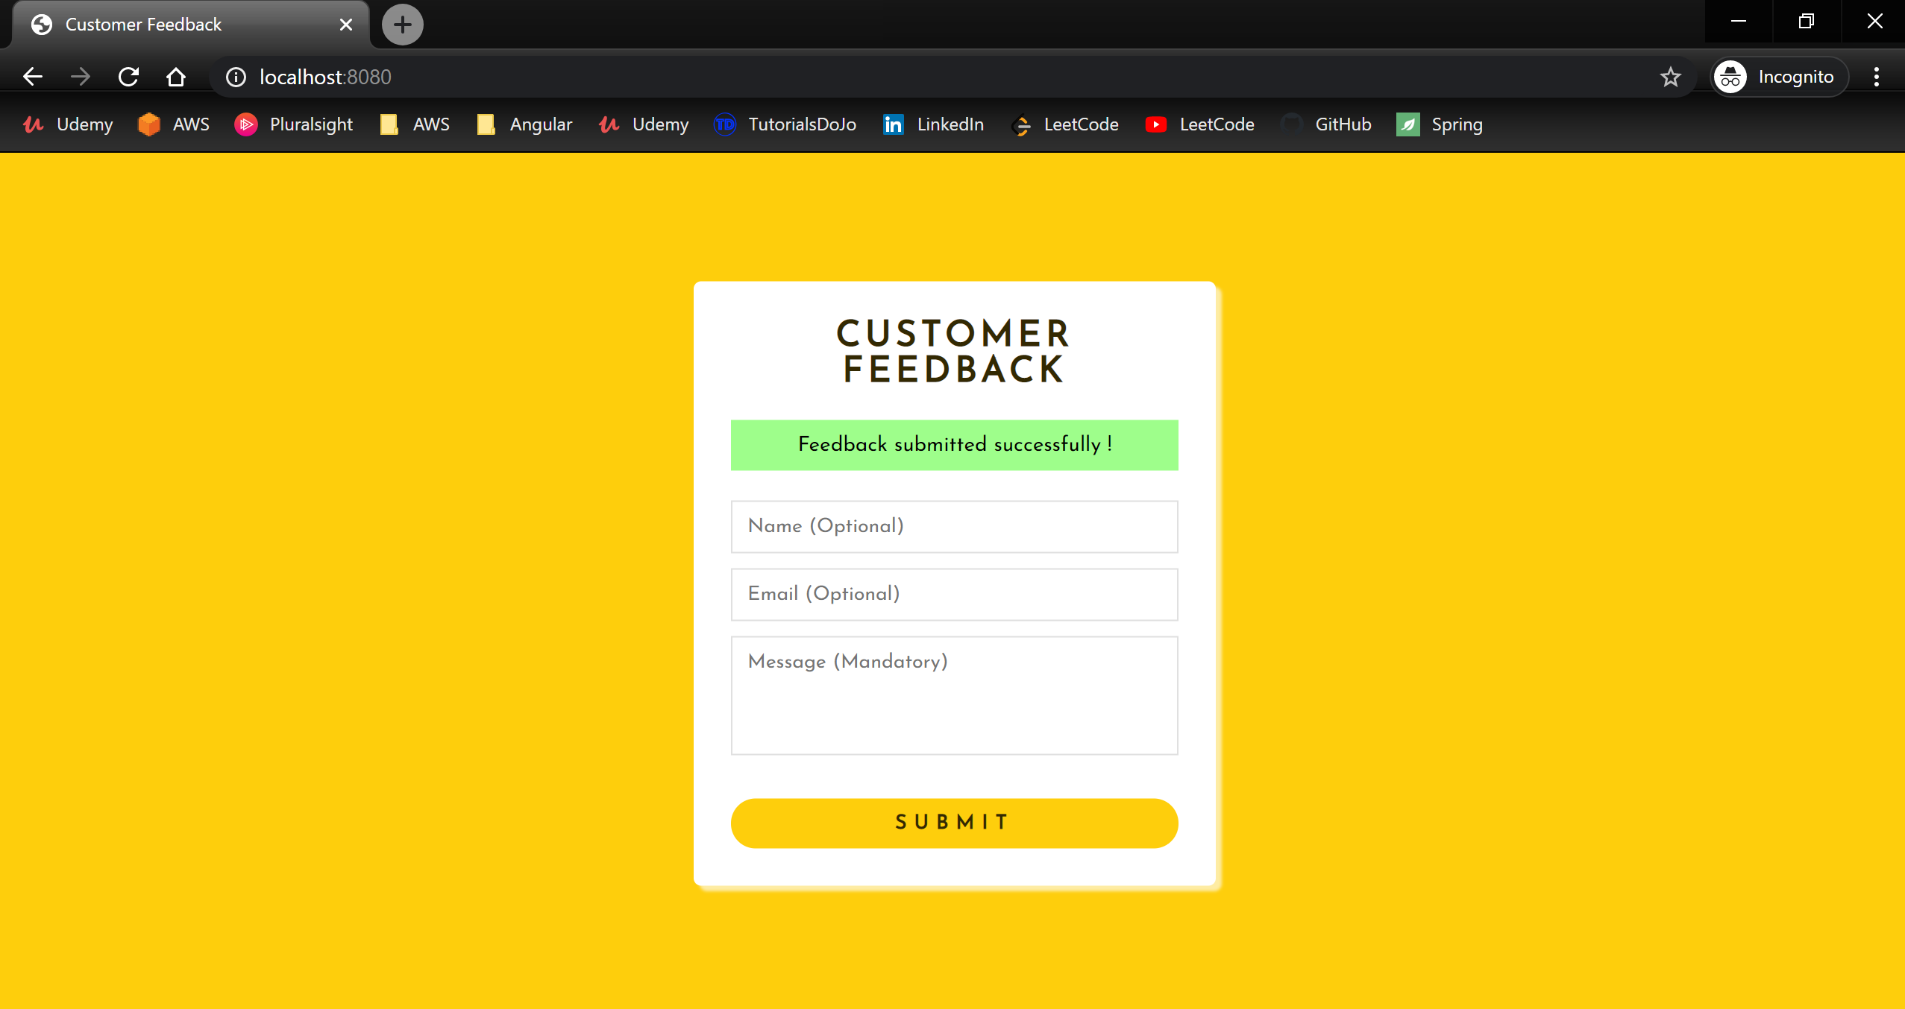

- Any other possible errors in saving the Feedback to DB

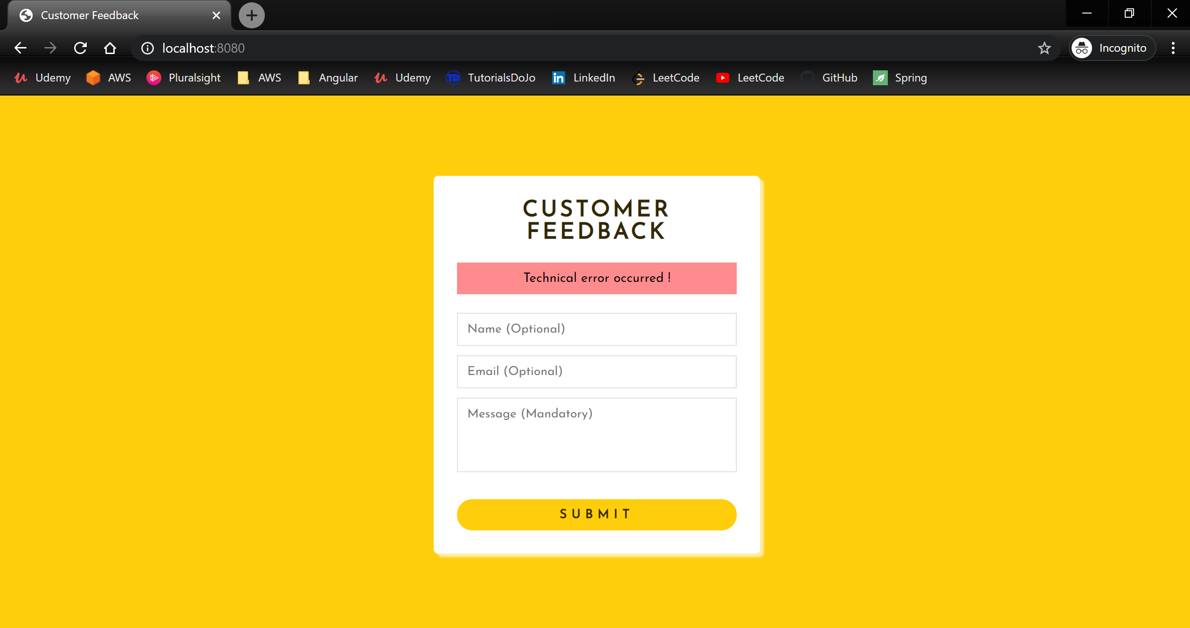

- Default error page

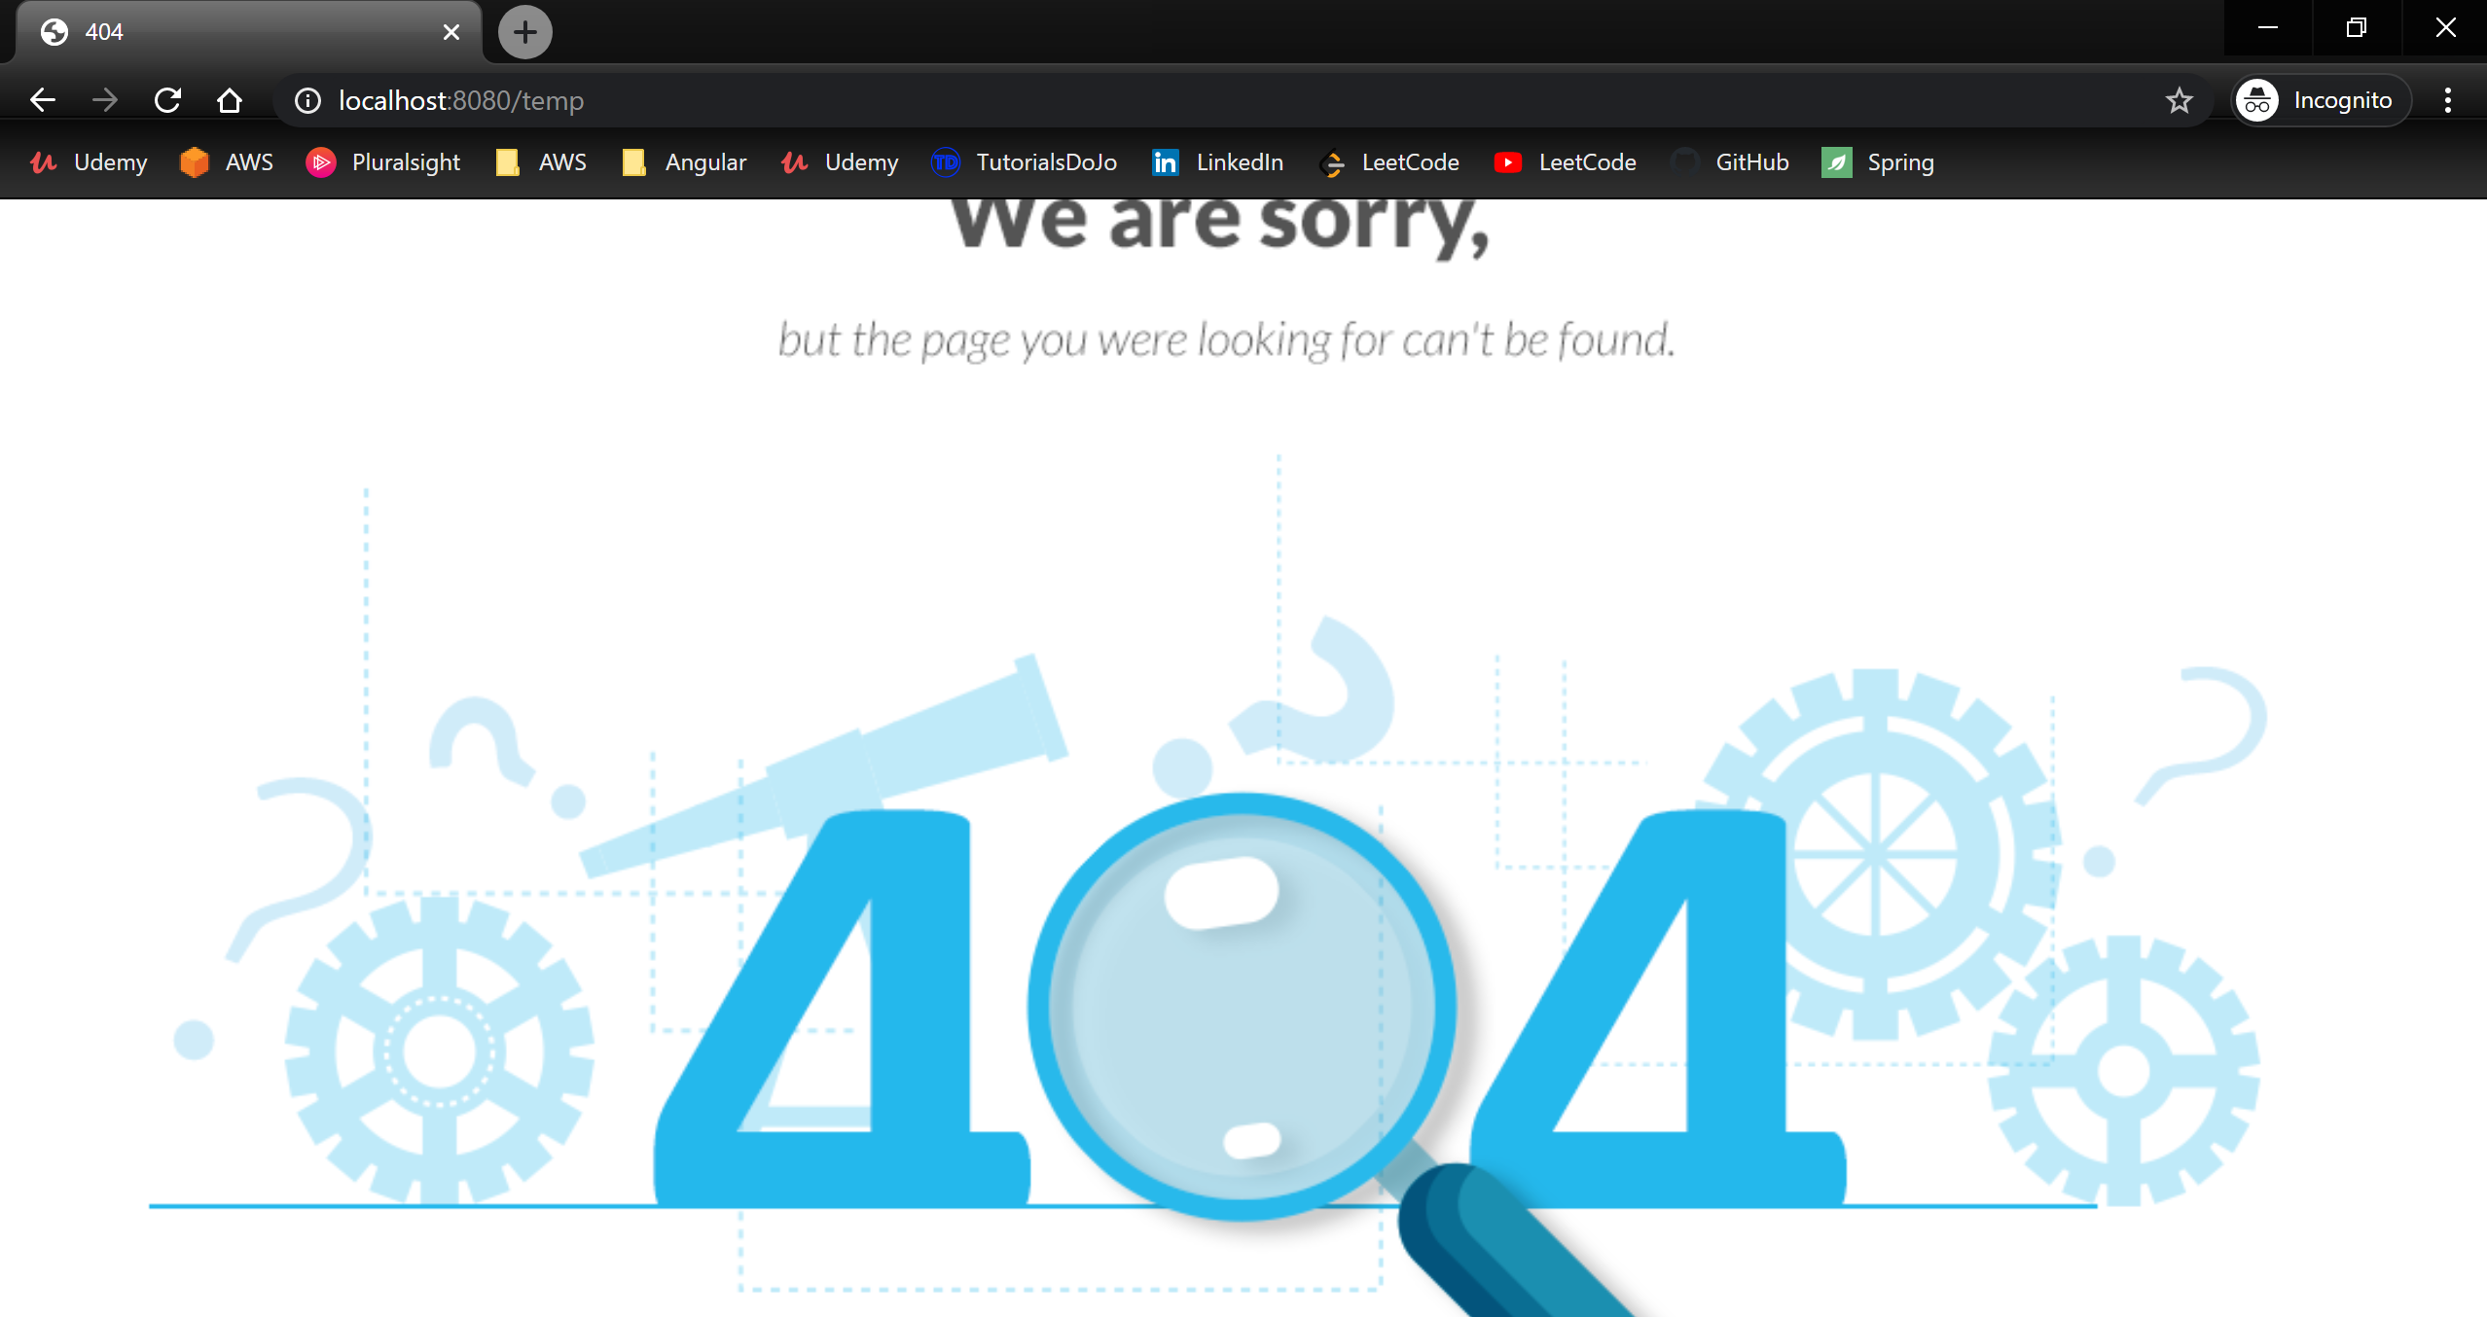

Customer Feedback Management – Admin – Story 2

